**Bash scripting:**

**#! --> shebang**

**/bin/bash --> shell**

**1. To check what are the shells present in the machine ?**

**Cat /etc/shells**

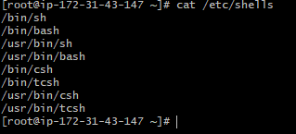

**2. To change current shell to another shell ?**

**Ex: enter sh it will go to sh shell**

**Similarly bash,csh,tcsh  
To quit from the shell type : exit**

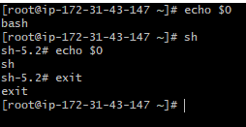

**3. To make two directory at a time?**

**Mkdir –p /sravan/scripts**



**4. How to show Output to screen**

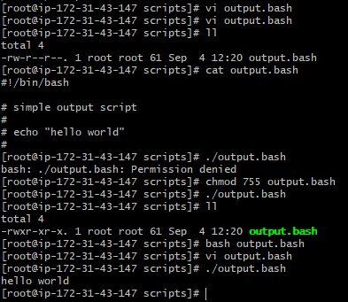

**5.To ways to execute the script file**

**./filename**

**Bash filename**

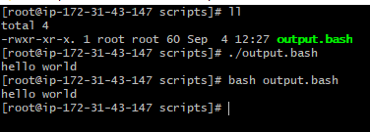

**6. Giving the variable**

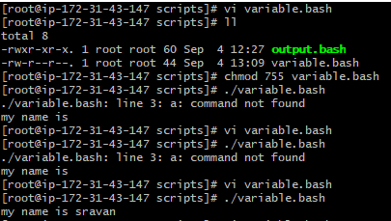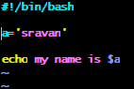

**7. using linux commands**

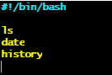

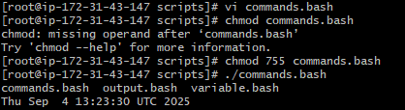

**8. input/output scripts:**

**Read --> take input from user**

**Echo --> print the output**

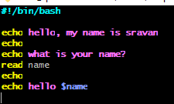

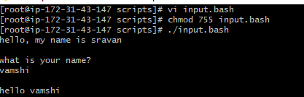

**9. Hostname script**

